PRESS RELEASE
For immediate release

Kiosk7: OudWestKiosk
A project by Gavin Wade mit Simon & Tom Bloor
3 November – 15 December 2007
Opening: Saturday 3 November 2007, 21.00 hrs
Location: SMART Project Space, Arie Biemondstraat 105-113, Amsterdam
Opening hours: Tue – Sat, 12.00 – 17.00 hrs

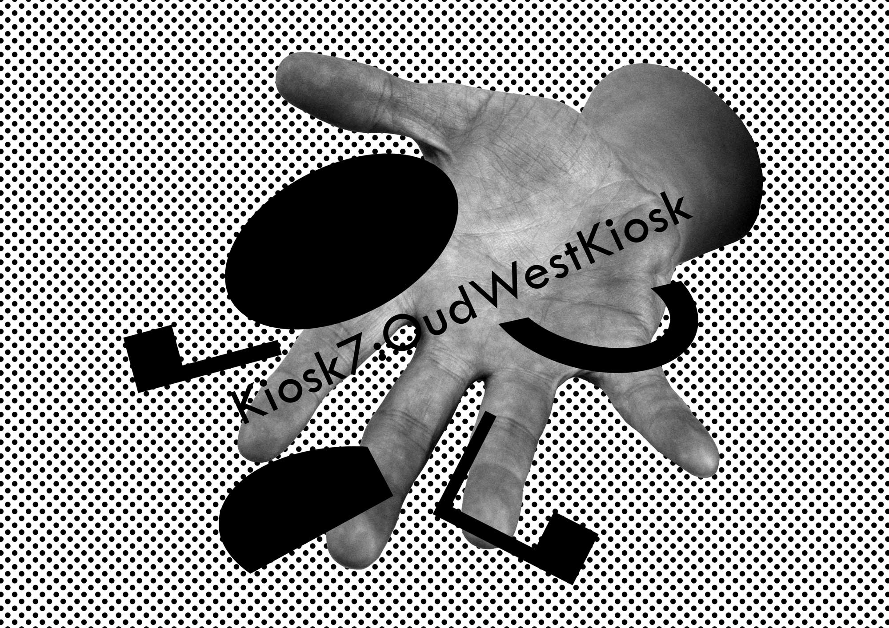

Gavin Wade mit Simon & Tom Bloor
Gavin Wade mit Simon & Tom Bloor are an artist group based in Birmingham. Their Kiosk project exploits two ellipsoid concrete buildings located among a set of enclosures created for Dudley Zoo in the UK in 1937 by the Russian architect Berthold Lubetkin and his young architects group Tecton. In 2005 the artists reclaimed Kiosks 1 & 2 from disuse to give them a new life and to distribute a specially commissioned free multi-part book, What are the senses?, to the zoo’s visitors.

They next proposed to find new functions for the kiosk design (from a for aquarium to z for zeppelin) by making the original designs mobile and sending them on new adventures around the globe. Recreating the form of two of the human shelters of the zoo, they are working on a global network of kiosks as artworks, each responding to the location where it is situated. Kiosk3: MerzKiosk was an offsite project for Merz, Magazin4, Bregenz, Austria, 2006; Kiosk4 will be a Balti kiosk for Birmingham; Kiosk5: KiteKiosk (with Nils Norman) will take place at the Folkestone Triennial, UK, 2008, and Kiosk6: Intellect&ComprehensionKiosk was part of Strategic Questions Venice, 2007. See also www.kiosk1and2.org

Kiosk7: OudWestKiosk for SMART Project Space in Amsterdam is an extensive, ongoing project that simultaneously functions as a competition, an art work and an exhibition. Earlier in 2007 UK based artists Gavin Wade mit Simon & Tom Bloor and SMART Project Space invited organizations within Oud-West to propose new functions for the kiosk. After an edifying response from a broad range of Oud-West groups and organizations four Kiosk proposals have been selected by the artists to be developed for the final round of the competition. The artists have selected the four kiosk functions they deem as promising the greatest benefit to the community and adding the greatest amount of new understanding of the public realm. These four proposals are the heart of the artwork and take the form of an exhibition:

ElevatorKiosk, the kiosk as an elevator to the guest studio and the roof terrace of the Merkelbach building at Da Costakade, proposed by M4gueststudio;
FloraKiosk, the kiosk as a natural oasis with plants and an air filtration system at a busy intersection in Oud-West, proposed by Beeldend Gesproken art library / gallery;
IslamicYouthKiosk, a kiosk that would serve as the base for a range of activities by young Islamic people, proposed by youth center Argan;
StoryTellingKiosk, an inter-generational and inter-cultural storytelling kiosk, proposed by Stichting Tijdgeest (Foundation Spirit of the Time).

Kiosk7: OudWestKiosk incorporates aspects of architecture, urban planning and social systems within a framework of localized and international aesthetics, forms and ideals. Each entry has been designated a section of the kiosk (bar, roof etc.) as a symbolic sculptural gesture and has been invited to provide materials for use in the exhibition space to represent the organizations’ ongoing activities and aspirations. The artists have worked with the material resulting from the proposals through the principle of collage, appropriating and adapting quotes by Berthold Lubetkin and have playfully collaged and written a special edition of the publication series SMART Papers.

The winning Kiosk will be selected by an international panel of experts and exhibition visitors. SMART Project Space aims to realize the winning kiosk proposal in the public space of Oud-West in 2008.

Extra activities during the exhibition
On 8 December extra activities will take place at SMART Project Space and in the neighbourhood of Oud-West organized by the participating groups: an artist talk by Lorenza Boisi, organized by M4gueststudio in collaboration with Transartists; a medicinal-plants-give-away action at a busy intersection by Beeldend Gesproken; a fashion show with Moroccan wedding dresses by Youth Center Argan and a reminiscence workshop by Stichting Tijdgeest.

Concluding international symposium
Related to the broader issue of the future of modern architecture addressed by the Kiosk project, the international symposium Forward! – on the revitalization of modern architecture will take place on 15 December under the moderation of architect, film maker and author Jord den Hollander. Guest speakers include: Owen Hatherley (philosopher, London); Marko Lulic (artist, Vienna); Dirk Snauwaert (artistic director Wiels!, Brussels) and Keyvan Lankarani (Avanti Architects, London).

Coded Cinema
November 2007

While working towards the re-opening of SMART Cinema, as a gesture of appreciation to our audience, SMART has developed a radical new approach to the cinematic experience. The new Coded Cinema offers 24 hour access to an intimate 12 seat film theater, allowing visitors to let themselves in at their own leisure, make themselves at home and enjoy the eclectically mixed programme of video art, experimental film, art house cinema and documentary film. The Coded Cinema is located in a small outbuilding adjacent to the main building. Each month the access code is distributed through an emailing for which you can register at the SPS website.

Programme November
In the framework of the project Kiosk7: OudWestKiosk, there is a three part programme in the Coded Cinema for the month of November. Gavin Wade mit Simon & Tom Bloor have invited the four participating groups to present a documentary or other film work that relates to their organization. The second part of the programme consists of two documentaries on Berthold Lubetkin, and is followed by a third part consisting of films selected by the artists.

Part 1
El Ingenioso Hidalgo Don Quijote de la Mancha, English subtitles, 10:00 min, 2005, a video by artist Jean-Baptiste Gannes, proposed by M4gaststudio
Dezelfde wereld maar dan Anders, a documentary on three artists from Beeldend Gesproken art library / gallery, in Dutch, 30:00 min, 2004
Historical film fragments of Amsterdam Oud-West from the City Archives, proposed by Stichting Tijdgeest, 3:00 min, fragments from the 1930´s
Loverboy, Lodewijk Crijns, in Dutch, 79:00 min, 2003, proposed by Stedelijk Jongerenwerk Amsterdam, unit Argan

Part 2
The New Architecture of the London Zoo, documentary by Laszlo Moholy-Nagy for the Museum of Modern Art New York, silent, 15:00 min, 1936
The Chosen People: The Architect, documentary by Russia Today, in English, 30 min, 2007

Part 3
Rashomon, Akira Kurosawa, in English, 88:00 min, 1950
Modern Times, Charlie Chaplin, in English, 85:00 min, 1936
Groundhog Day, Harold Ramis, in English, 101:00, 1993
Night on Earth, Jim Jarmush, in English, 129:00, 1991

For further information please contact Hilde de Bruijn, Head of Exhibitions: hilde@smartprojectspace.net

For press images: http://smartprojectspace.net/kiosk/press/

Further information and updates visit: www.smartprojectspace.net

Location map: www.smartprojectspace.net/info/location

Kiosk7: OudWestKiosk is supported by Amsterdams Fonds voor de Kunsten; Stimuleringsfonds voor Architectuur; Henry Moore Foundation, and Cultuurfonds Stadsdeel Oud-West.

SMART Project Space is generously supported by Mondriaan Foundation; Gemeente Amsterdam; Bureau Broedplaats; Stichting Doen; VSBfonds; Filmfonds; Prins Bernhard Cultuurfonds.

